**Model Development Phase**

|  |  |
| --- | --- |
| Date | 15 March 2024 |
| Team ID | 739877 |
| Project Title | WCE Curated Colon Disease Classification using Deep Learning |
| Maximum Marks | 10 Marks |

**Initial Model Training Code, Model Validation and Evaluation Report**

**Initial Model Training Code (5 marks):**

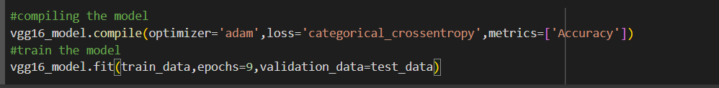

**Model Validation and Evaluation Report (5 marks):**

|  |  |  |
| --- | --- | --- |
| **Model** | **Summary** | **Training and Validation Performance Metrics** |
| Model 1  (vgg16) |  |  |